Class Link log in:
Go to https://launchpad.classlink.com/leonschools
Username: studentnumber@edu.leonschools.net
Password: 12345

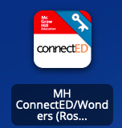
Reading –
- Log in to Class Link
- Click “ConnectEd”
- Click “Launch”
- To access assignments, select the green circle for “To Do”
- There will be some instructions, and all of the videos and activities for that day will be under resources on the right hand side.
- Once all of the videos and activities have been completed, click submit.

*For assignments in the Your Turn Workbook, click on the pencil to write and then click on the blue floppy disk with a pencil to save work to binder when finished.*

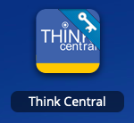
Math –
- Log into Class Link
- Click “Think Central”
- Click “Things to Do”
- Then, select the lesson for that day.
- For extra practice, there will be Mega Math and Curious George interactive videos for each week.
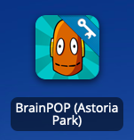
Social Studies and Science -
- Log into Class Link
- Click “Brain Pop”
- Click “Dashboard” found at the top of the page
- There will be two assignments each week (1 for social studies and 1 for science). Each assignment includes a video and a quiz.
- First, watch the video or “movie”
- Then, take the quiz

